<https://www.rcsb.org/chemical-sketch>

**N-甲基乙酰胺**

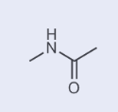

<https://www.leyan.com/79-16-3.html?bd_vid=12334838973182282448>

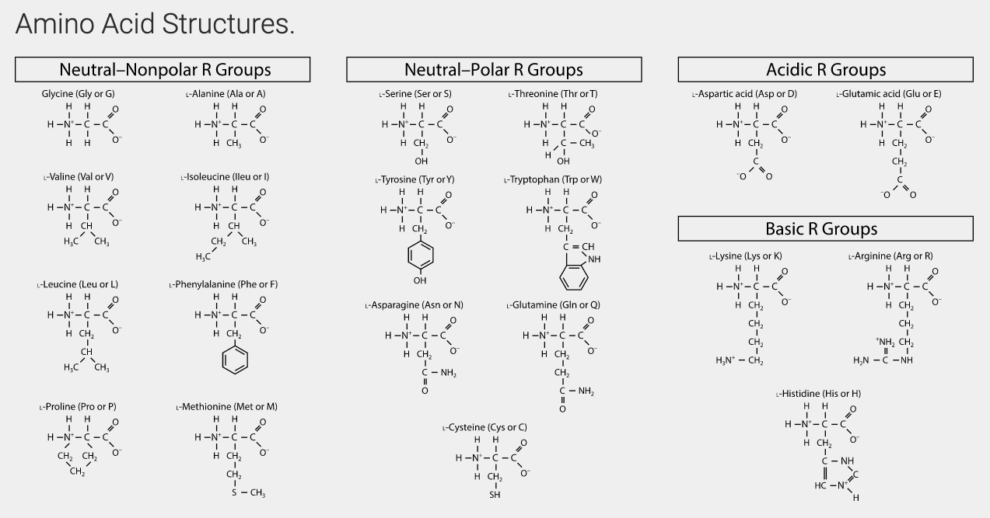

<https://www.promega.com.cn/resources/tools/amino-acid-chart-amino-acid-structure/>

**Peptide Bond Formation**

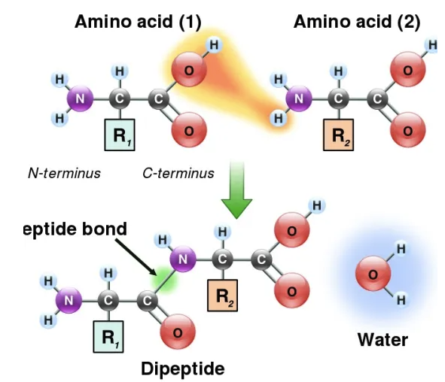

<https://pediaa.com/what-is-the-difference-between-amide-and-peptide-bond/amp/>

<https://www.rdkit.org/>

<https://www.rdkit.org/docs/cppapi/classRDKit_1_1Atom.html>

<https://pubchem.ncbi.nlm.nih.gov//edit3/index.html>

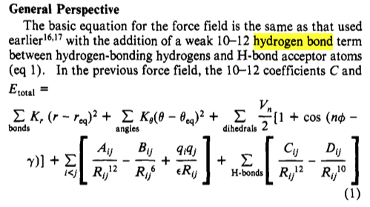

16200 atoms

env OMP_NUM_THREADS=8 /usr/local/Cellar/lammps/20220623/bin/lmp_mpi -sf omp -in *.in

Loop time of 137.909 on 8 procs for 10000 steps with 16200 atoms

Performance: 6.265 ns/day, 3.831 hours/ns, 72.511 timesteps/s

648.1% CPU use with 1 MPI tasks x 8 OpenMP threads

mpirun -np 8 /usr/local/Cellar/lammps/20220623/bin/lmp_mpi -in *.in

Loop time of 144.099 on 8 procs for 10000 steps with 16200 atoms

Performance: 5.996 ns/day, 4.003 hours/ns, 69.397 timesteps/s

93.5% CPU use with 8 MPI tasks x 1 OpenMP threads